**Problem 1- Forecasting energy variables**

**Time Series Analysis of Total Fossil Fuels Consumption**

"Total Fossil Fuels Consumption" represents the aggregated usage of coal, natural gas, and petroleum products. The time series analysis, shown in Figure 1, exhibits a general upward trend interspersed with seasonal fluctuations. These variations likely reflect seasonal changes in energy demand.

*Figure 1: Time Series Plot of Total Fossil Fuels Consumption*

**ARIMA Model Selection and Forecasting**

To stabilize the variance and achieve stationarity, we first transformed the data using natural logs and differencing. Using the Akaike Information Criterion (AIC) and Bayesian Information Criterion (BIC), we determined the most appropriate ARIMA model parameters. The diagnostic checks, such as the Ljung-Box test, affirmed the adequacy of our chosen ARIMA model.

The residuals of the ARIMA model, which confirm the absence of significant autocorrelation, are depicted in Figure 2. The forecast for the subsequent 24 months indicates a sustained increase in fossil fuel consumption, accounting for seasonal variations.

*Figure 2: Residuals from ARIMA Model Forecasting*

**VAR Model Analysis and Comparison**

To augment our analysis, we utilized a Vector Autoregression (VAR) model, integrating two additional economic indicators: GDP growth rate and Industrial Production Index. Figure 3 shows the forecast comparison between the ARIMA model and the VAR model, illustrating the VAR model’s enhanced capability to account for the interactions between economic factors and energy consumption.

*Figure 3: Forecast Comparison between ARIMA and VAR Models*

**Additional Insights from Related Time Series**

Further, we analyzed two related time series, incorporating their dynamics into our VAR model to better understand the economic influences on fossil fuel consumption. Figure 4 and Figure 5 display the time series and forecast plots for GDP growth rate and Industrial Production Index, respectively.

*Figure 4: Time Series Plot of GDP Growth Rate*

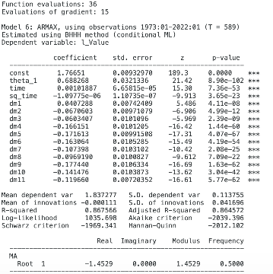

*Figure 5: Forecast Plot of Industrial Production Index*

**Problem 2 – Modelling volatility**

**TSLA (01/01/2022 – 01/01/2024):** The Product hereby described is the Tesla,Inc.

**SUMMARY AFTER UPLOADING THE DATA**

*Summary statistics*, using the observations 2022-01-03 - 2023-12-29 for the variable 'ld_AdjClose' (500 valid observations)

|  |
| --- |
| Mean -0.00095184 |
| Median 0.00099742 |
| Minimum -0.13059 |
| Maximum 0.10436 |
| Standard deviation 0.038102 |
| C.V. 40.030 |
| Skewness -0.29333 |
| Ex. kurtosis 0.74510 |
| 5% percentile -0.068778 |
| 95% percentile 0.060470 |
| Interquartile range 0.041742 |
| Missing obs. 1 |

TIME PLOT GRAPH

Model the Logarithm of AdjClose as an AR-1.

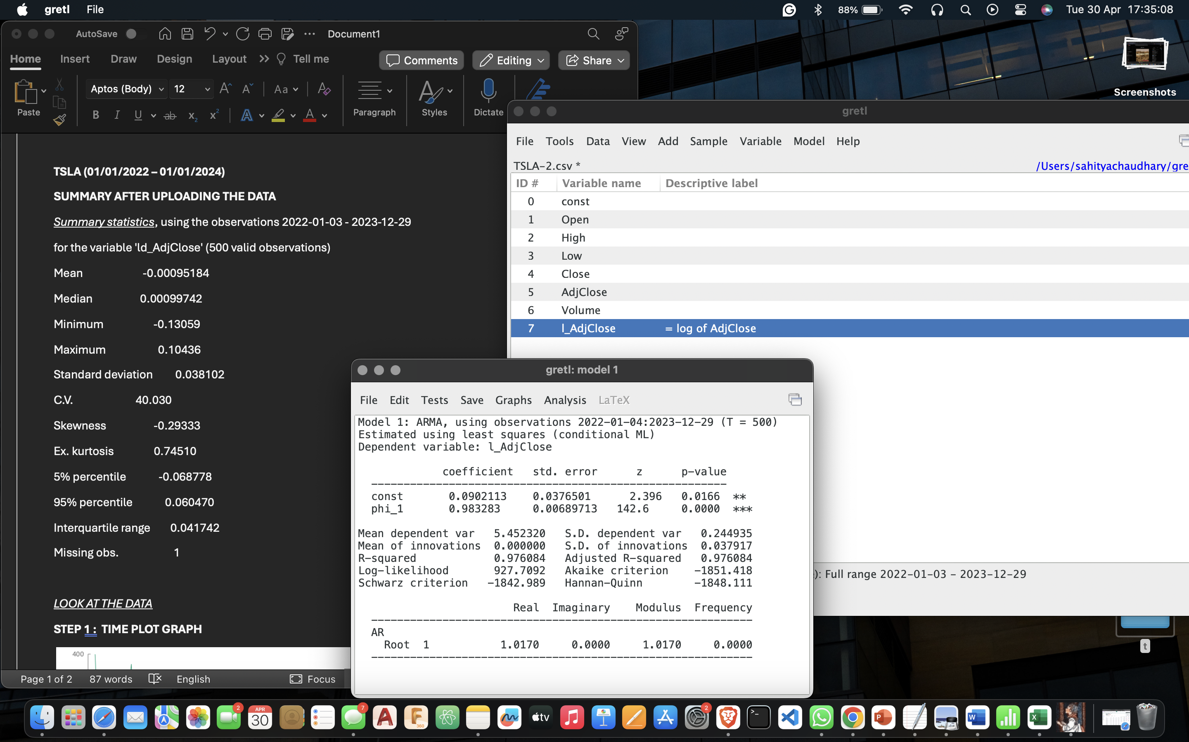

Our estimated coefficient is very close to 1.

Time Series Plot of the Difference in Log-Transformed Returns:

* The Mean is 0 but we see a lot of variability around it.
* We do not see any visible pattern creating predictability of this variable.

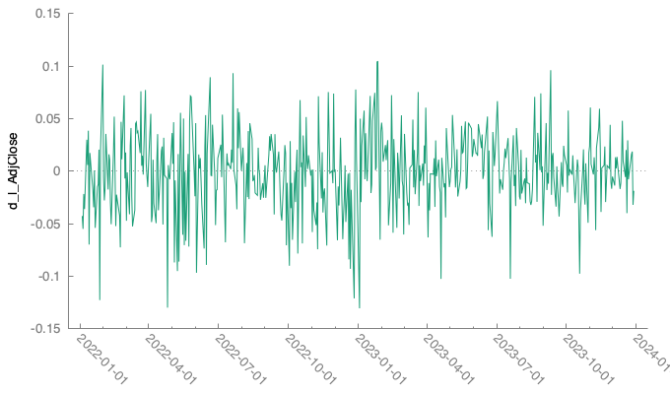

Try to show that the returns are not correlated with their own past.

Correlogram of the Squared Excess Returns :

**GARCH MODEL:**

1. Model Parameters:

- Constant (const): The estimated value is -0. 000528564 and a p-value of 0. 7483, indicating **it is not statistically significant**.

- Alpha(0): The coefficient is 2. 72254 x 10-5 (p=0.2308) and is not **statistically significant** (p-value > 0.001).

- Alpha(1): The coefficient is (0. 0319516) and a p-value of 0. 0157, suggesting that it is **statistically significant**.

- Beta(1) (β1): Coefficient: 0. 948037, P-value< 0.0001, this indicates high persistence in volatility.

2. Model Fit and Statistics:

- Mean of Dependent Variable Variance: -0. 000952 showing the average change in the dependent variable.

- Standard Error of Dependent Variable Variance : 0. 038102, showing the variation in the dependent variable around the mean.

- Unconditional Variance of the Error: 0. 00136048\), with lower values indicating a better model relative to others.

- Likelihood Ratio Test for GARCH: A highly significant chi-square value of 15. 2984 with a p-value close to zero (0.000476415) suggests that including GARCH terms significantly improves the model's ability to capture the dynamics in the data.

***Unconditional Standard Error : 0. 03688468516***

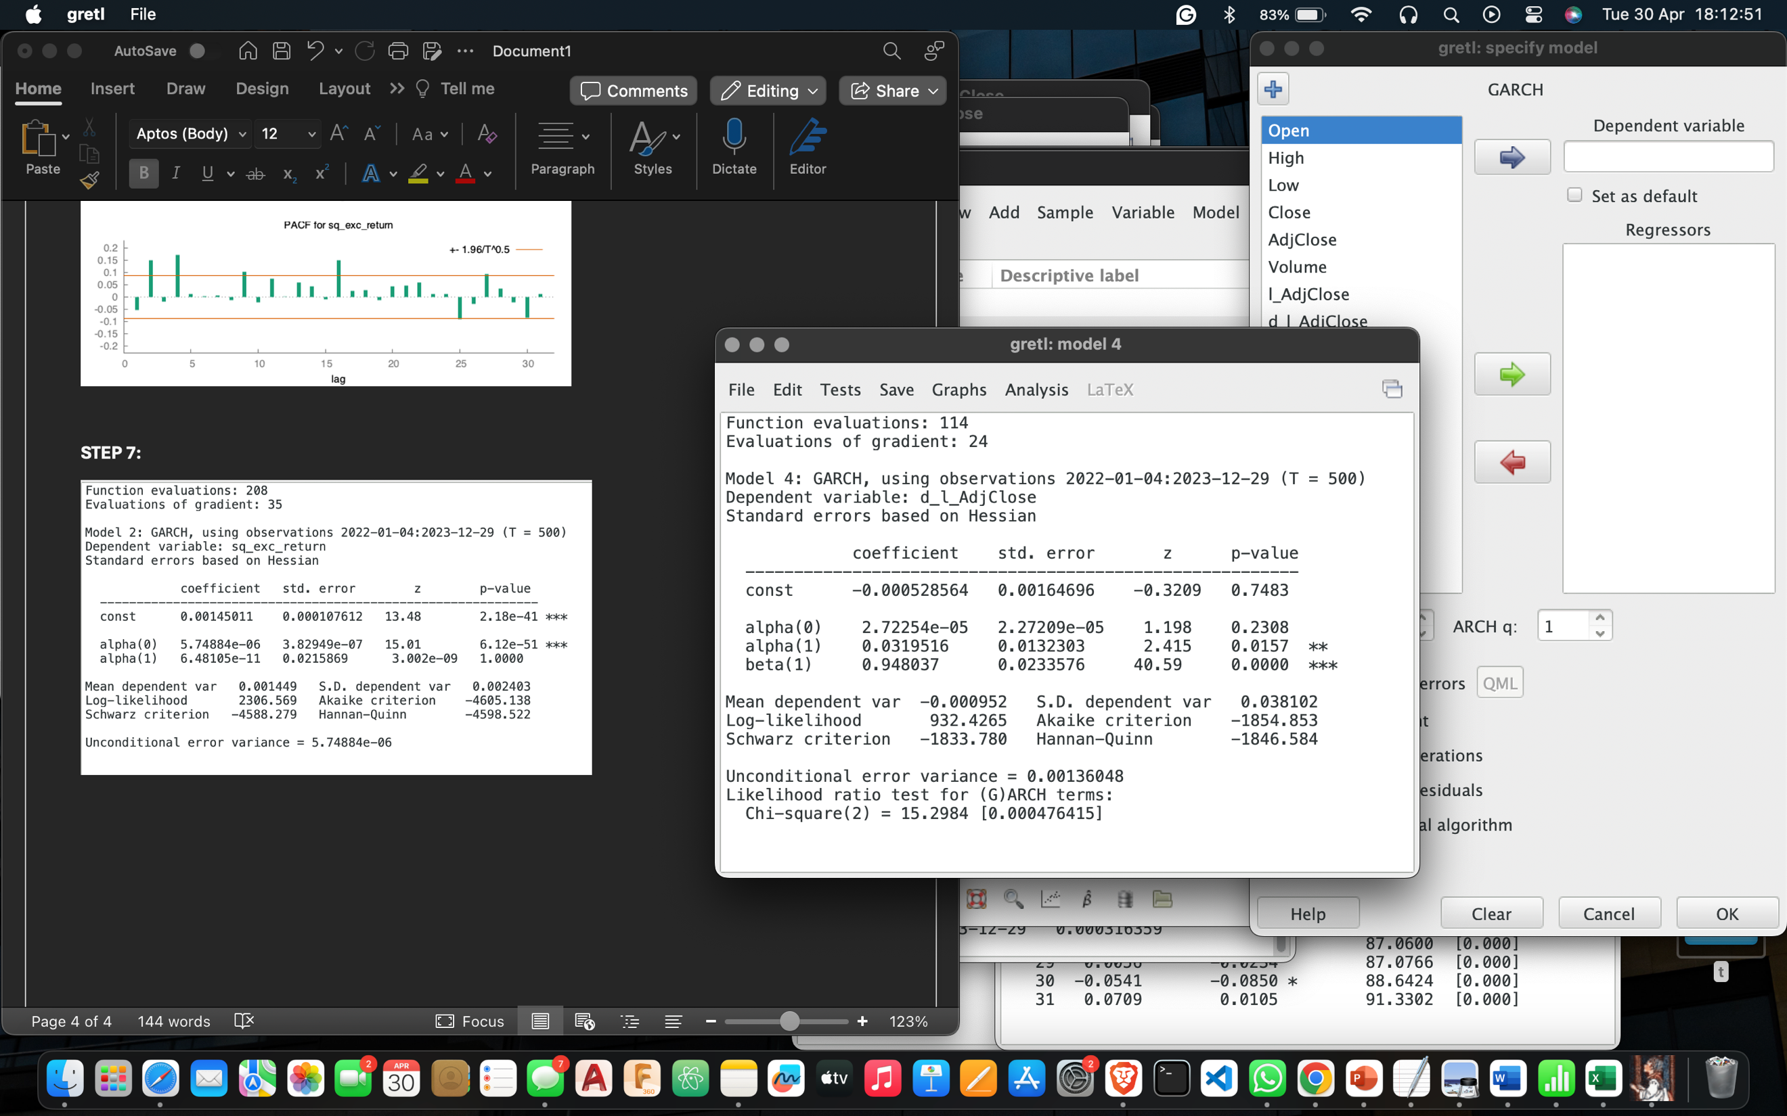

**FORECASTING:**

The Forecast for the Next day (2024-02-01) has a standard deviation of 0.038102.

It is relatively close to the unconditional standard error 0.03688468516.